Skills Workshop # 7: Poster and PowerPoint Presentation

Speakers: Ms. Pam Truesdell, RET Engineering Resource Person
Date: Tuesday, July, 10, 2018
Time: 9:00-11:00 am
Venue: University of Cincinnati, Swift, Room 608

Prepared by:
Marie Pollitt, Felicity-Franklin Middle School, Felicity, Ohio
RET Participant for Project #4: “Air Quality Air Quality Monitoring Near a Major Roadway”
Ms. Pamela Truesdell provided the workshop on Tuesday, July 10, 2018 from 9:00-10:00 am at the University of Cincinnati in Swift, Room 608. She is the RET Engineering Resource Person (EERP) for the Research Experience for Teachers (RET) program. She earned a B.A. and MAT in History, as well as a BS in Education from UC. A teacher for 30 years in Cincinnati Public Schools, she taught history, mathematics, computer science, and engineering. She served as the chairperson for the Engineering Department at Western Hills Engineering High School and was part of the committee that helped the school receive National Certification from Project Lead the Way Engineering in 2010. In 2011, Ms. Truesdell was selected for the Albert Einstein Distinguished Educator Fellowship program, and she served two years at the National Science Foundation (NSF) l working on the Research Experiences for Teachers program in the Engineering Directorate. She also authored a short format book, Engineering Essentials for STEM Instruction: How do I infuse real-world problem solving into science, technology, and math? (ASCD Arias), which was co-released by ASCD and NSTA Press in April, 2014.
Ms. Truesdell began her session by describing the importance and objectives of making a poster, see Figures 1 and 2 below. She emphasized how posters communicate information to the audience. She informed that especially the primary audience for the poster to be created by the participants at the end of the Summer RET program is their students, whereas the secondary audiences include their school administrators, peer colleagues and their student’s parents. She noted how this poster can serve as a means of summarizing and synthesizing Challenge-Based Learning (CBL) and Engineering Design Process (EDP) as the two teaching pedagogies to be used in their teaching. It can be designed to start conversations, inform colleagues, parents and administrators of intended work and advertise the benefits of the CBL and EDP to them. She told that by creating the poster for the Summer RET Program, they will gain the experience to create a similar, but different poster, to participate in future professional conferences, where the audience will be different. Ms. Truesdell emphasized again the contents of the poster must be selected keeping the audience in mind.

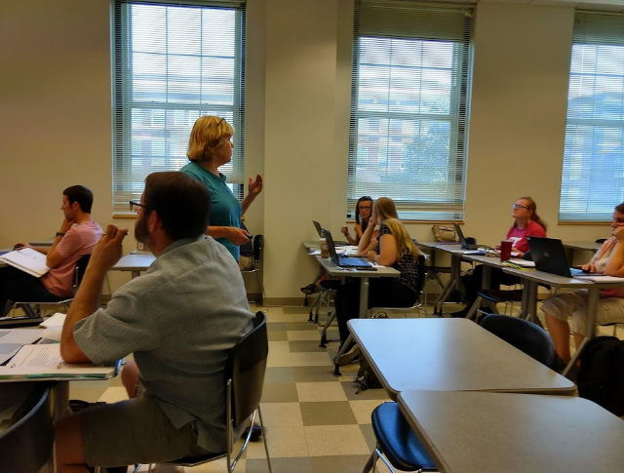  Figure 1: Ms. Truesdell Emphasizing the Importance | 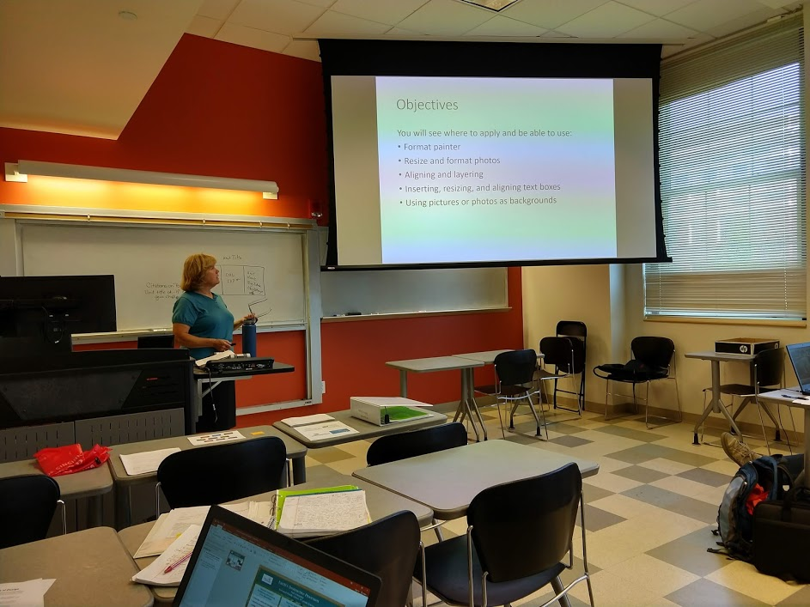  Figure 2: Ms. Truesdell Sharing the Objectives

Ms. Truesdell made suggestions to make an appealing poster. Avoid placing information on the edge of the poster. She suggested giving a one-inch margin around the poster to help the RET Participants remember this suggestion. The font of the poster should be at least 28 point and maintain consistency among font size; for example, all major headings should have the same size font. The color scheme plays a vital role in the appearance of the poster. Applying dark color letters on top of a dark background will make it difficult to read the text, for example using black letters over a deep blue color background. In regards to the amount of text on the poster, she suggested to choose phrases over complete sentences and use bullets if several phrases are presented. Be sure to include relevant and interesting pictures to grab the viewer's’ interest and to convey the message. Most importantly, include some white space to avoid it being too busy.
After reviewing these basic suggestions for poster design, she went over the summer poster requirements: inclusion of the NSF logo; acknowledgements of participating RET teachers, staff and faculty; ensuring the clear display of the RET project grant number, inclusion of the University of Cincinnati (UC) logo along with the teacher’s name, school name, subject taught, grade level, and the district logo are all necessary. All of these elements should be placed on the top banner or in the corners of the poster. The layout of the poster, should be broken up into three sections or panels: research completed, implementation of challenge based learning and engineering design process into the classroom, and an introduction of the developed unit.
Ms. Truesdell went over the principles and elements of design: unity and variety, emphasis and focal point, scale and proportion, balance, rhythm, line, shape and volume, texture and pattern, illusion of space, illusion of motion, value, and color. As a class, the RET Participants looked over many different posters and were asked if they would stop and look at the poster or keep walking. We identified components of the posters that were appealing and areas that needed improvement.
Lastly, the RET participants transitioned to the activity Let’s Play: Fix the Poster. The objectives of this activity were to apply Format Painter to select the text or graphic that has the formatting that one wants to copy, resize and format photos, align text boxes, and use pictures or photos as backgrounds. As the RET Participants viewed example posters, they applied what was learned from the workshop to critique the sample posters. This was a first-hand learning experience.

